Melle Dijkstra

melle210202@gmail.com

Description

This document describes in general what the project is about and how it will come to realize

Product Concept document

Cheery

# Version Control

|  |  |  |
| --- | --- | --- |
| Version Number | Date | Description of change |
| 1 | 13-9-2015 | Begin documentation |
| 2 | 25-10-2015 | Finishing up PCD |
| 3 | 29-11-2015 | Corrections |

# Table of contents

1 Version Control 2

2 Table of contents 3

3 Introduction 4

3.1 Project Concept Document 4

3.2 General Information 4

4 The Project 5

4.1 The Concept 5

The idea 5

How it works 5

Possible ideas 5

4.2 Project Management 6

Project Planning 6

Programming Environment 6

Target Platform 6

4.3 Network Diagram 7

5 The Customer / User 8

5.1 Who is the customer? 8

5.2 Types of users 8

Normal users 8

Product Administrators 8

6 The Product 8

6.1 Product Requirements 8

6.2 Flow of events (use-cases) 8

Users 8

Admins 8

7 Goals 9

7.1 Features 9

7.2 How will the product be promoted 9

8 Graphical Designs 9

9 The Extras 10

9.1 Potential Features 10

9.2 Maintenance of the Project 10

Domain name 10

Bugs, glitches and errors 10

Site Content 10

New Features 10

# Introduction

## Project Concept Document

The purpose of this project concept document is to identify the project idea and turn it into a realized product. It provides a basic understanding of the project and the content of it. This document will define the basis of the project and explain how certain aspects of the design work.

## General Information

The product’s name as of 13-9-2015 is “Cheery” because it fits the project. The name can change throughout project development.

Project / contact information

|  |  |
| --- | --- |
| Developer | Melle Dijkstra |
| Project Name | Cheery |
| Customer | ROC Friese Poort |
| Development Time | 20 weeks starting 20-8-2015 |

Melle Dijkstra – [melle210202@gmail.com](mailto:melle210202@gmail.com)

# The Project

## The Concept

### The idea

The idea of the project is a “social network” where you can share interests with friends and strengthen your relation between people in your friend group.

This is done by playing little games and helping each other with challenges together. What these games are exactly, is not yet clear. But don’t confuse this social media with Facebook or Twitter. It’s more for groups instead of you alone having a profile and updating statuses. The idea is to get to know everyone who you share the group with.

### How it works

You require an account which you can get by visiting the site or if an app is available you will be able to register an account via the app.

When you join for the first time you make an account and make a group and then you have the option to invite others to join the group you created. A few of the option you have are creating lists to share with others in the group, also you have a couple of “games” or challenges to complete or beat each other in. These little games can vary from taking the weirdest selfies and/or playing simple games like hangman. You can also play challenges with your group and score points with the whole group instead of yourself. In later updates you can play against groups and compete for the first spot.

### Possible ideas

The main thing the product has to do is have a fun time with friends on the site/app and sharing stuff with friends. The exact “games” or “challenges” that will be available are not yet established. If it is possible to make an app of this idea within the given time then that will of course be implemented. But that’s going to take time learning everything around app development.

## Project Management

### Project Planning

Google Drive:

[Cheery Project Planning.xlsx & Cheery Gantt Planner.xlsx](https://drive.google.com/folderview?id=0B3hR-3NDUXJBNjBVUUZRN05ZNTQ&usp=sharing)

If you don’t have internet use these local links (and have the files on your PC):

[Cheery Gantt Planner.xlsx](Cheery%20Gantt%20Planner.xlsx)

[Cheery Project Planning.xlsx](Cheery%20Project%20Planning.xlsx)

### Programming Environment

The programming environment will focus on web based development. The product will be hosted on a server with Apache, PHP and MySQL. Git will be used for version control and sharing files with project members as first option. If Git is too complicated for this small project, I won’t use version control but use old trusted backups of the files. The cloud server for the project will be hosted at digitalocean.com. That is because you can tweak everything on the cloud server at digitalocean.com like which software to use or which OS will be running on the cloud server.

### Target Platform

The Cheery project will be web based and targeted to people using the internet. First desktop will be the primary goal. In a later stage mobile will be supported. But desktop is the first thing where the application has to work. In the back-end there will be an API, so other applications can access some data of the Cheery project. It can also be used for the app to get information.

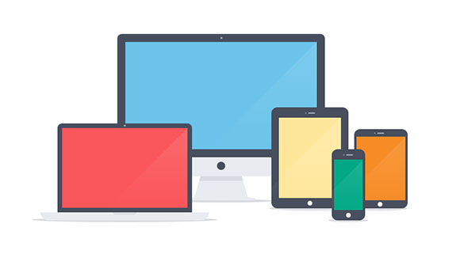

## Network Diagram

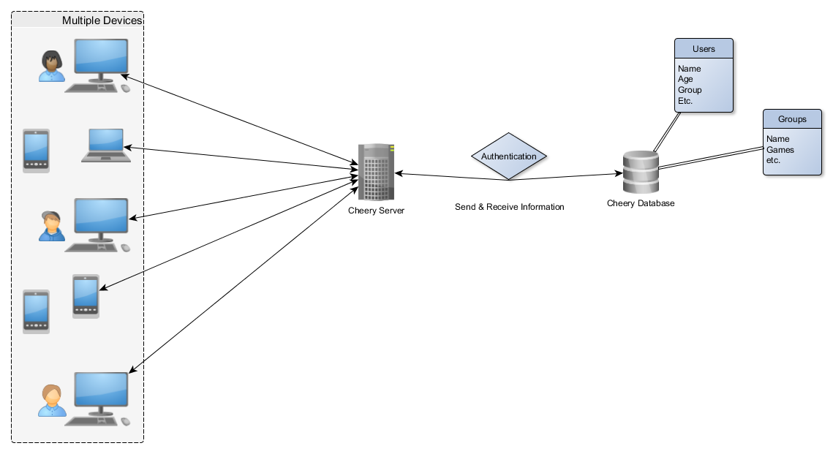

# The Customer / User

## Who is the customer?

Who is the user of the site/app/product? Everyone has the option to download the app or use the site when it’s available. But the main focus is the age range of 10 to 50 years old. There isn’t a restriction about the age but the people using the product are probably going to be in that range.

The application is also targeting people who want to have a fun time playing little games with their friends.

## Types of users

### Normal users

The normal user can make an account and also make groups. He can invite people to join the groups and do the standard things in the app like the mini games.

### Product Administrators

The administrators are able to alter the database from “behind the scenes”. They can change account, group, games and all the other things stored in the database.

# The Product

## Product Requirements

In the case of there being an app, it will only be made for android. iOS Development will take too long to realize. Making the app available for other devices is going to cost too much time and wouldn’t be possible to finish in the given time. After the deadline it is possible to create application for more devices.

## Flow of events (use-cases)

The use-case diagrams will be better explained in the Project Definition Report

### Users

1. User makes an account or logs in
2. User can creates a group or join another group
3. Invites others to the created or joins a group himself
4. They share things together and play games with each other

### Admins

1. Admin is given an account and logs in when verified
2. Admin can alter database information
3. Admins can change user profiles and groups (only if needed)

# Goals

## Features

1. Able to make an account for normal users
2. Everyone can create groups
3. Everyone can invite others to their group
4. Group admin can change if others can invite to group
5. Points System

## How will the product be promoted

The product won’t officially be promoted because it’s a school project. But when the project would be for real, Facebook promotion would be a choice. Also the Google Developer (console) is going to track the site for the ranking in Google’s search system.

# Graphical Designs

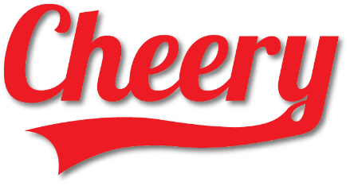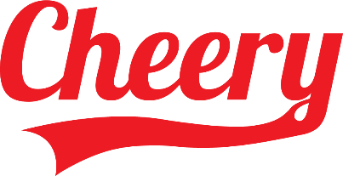*First logo designs*

*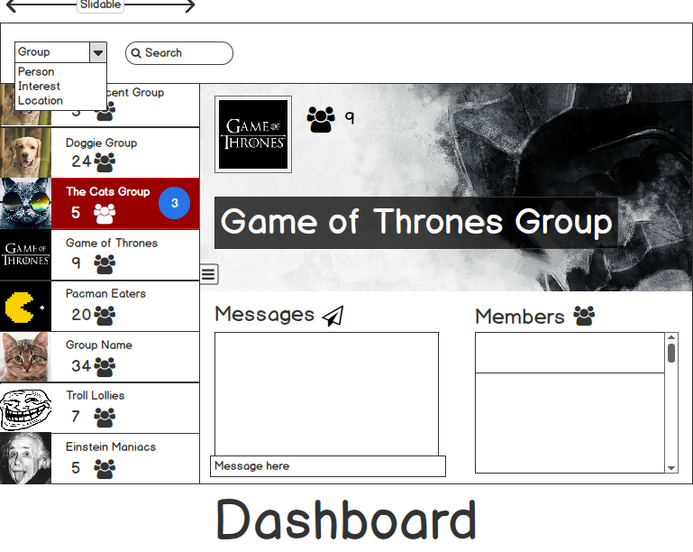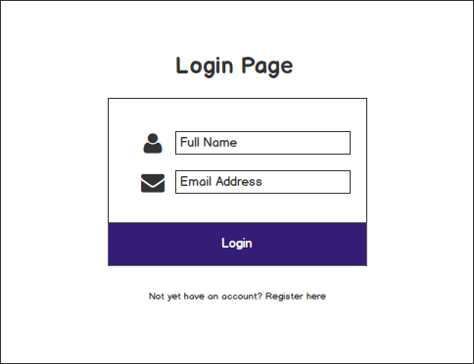User Interface (UI)*

# The Extras

## Potential Features

* Let the users themselves create little games.
* No page refreshes with certain functions
* Chat function to chat with each other

## Maintenance of the Project

### Domain name

When the product will finally be finished it will last at least a year because the domain name won’t be available anymore after 1 year. Or there has to be paid to extend the lifetime of the domain name. Because this is a school project I will cancel the payment for the domain name and keep the server because it’s always handy to have.

### Bugs, glitches and errors

If there are any small bugs, glitches or errors I will maintain the product by fixing them. Big problems or an incorrect design choice will not be fixed. If it works it works. And you can only learn from it, and do it better on the next time.

### Site Content

The content on the site will be crowdsourced so the programmer doesn’t have to maintain the site by adding new text or images. Crowdsource means that the application will be filled by the people that use it. The application is just a medium so they can share information.

### New Features

After the project has ended it depends on free time for adding the extra functions and options that haven’t been implemented yet. It also depends on how successful the product will be in the end result for maintaining it. You never know if a school project can turn into a millions product.